**PROJECT 2**

**GEOGRAPHY DATABASE DOCUMENTATION**

Assumptions and Design choices:

* Entity CONTINENT which will maintain data of all continents.
* WATER_BODIES is a generalization of RIVERS, LAKES, SEAS, CANALS, OCEANS.
* Entity POPULATION_HISTORY maintains Year and Population data of country and state.

Relations:

* “Country_Maintains” relation relates POPULATION_HISTORY maintained by a particular country.
* “State_Maintains” relation relates POPULATION_COUNTRY maintained by a particular state.
* A Country “belong_to” to a continent.
* A Country “has” many States and a State “has” many Cities.
* A Country and State has a capital city.
* A Waterbody can be adjacent or it can intersect to many cities, countries, states and continents.

Part 1:

EER Diagram :

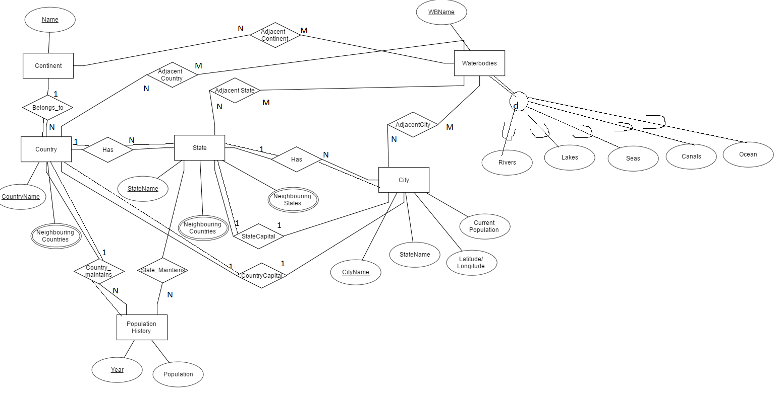

Part 2:

Relational Schema :

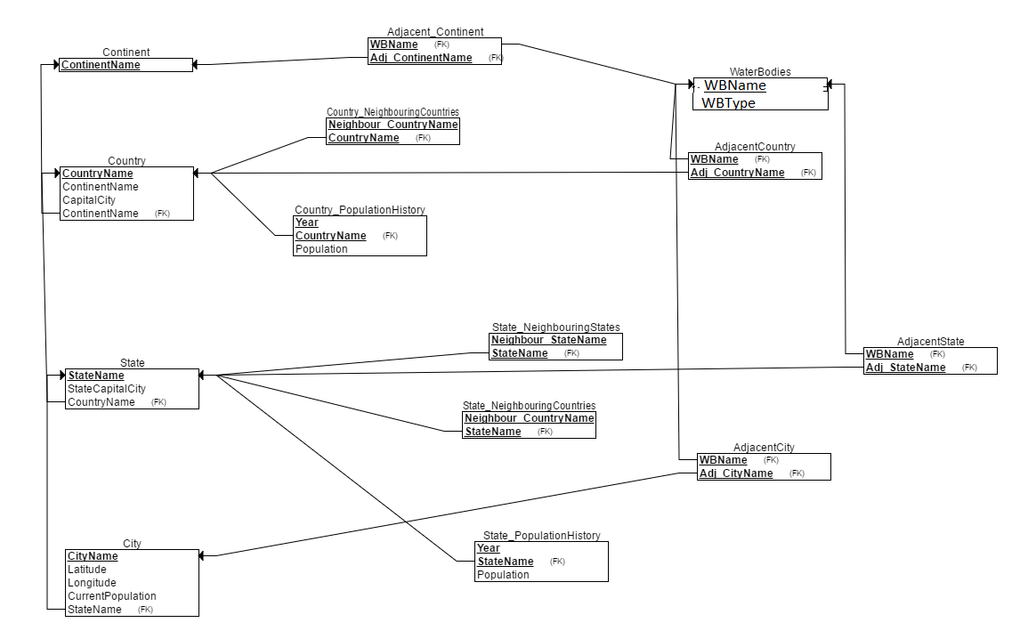

Choices Made during EER to Relational Mapping:

1. Country maintains continent name as Foreign key, State maintains country name as foreign key and city maintains state name as foreign key
2. The neighbours to a country are placed in a separate table with both Country name and its neighbour country name as primary keys ,because country can have many neighbours so it is a multivalued attribute. Also neighbouring countries and neighbouring states to a state are placed in separate table in the same way.
3. Country population history table has year and country name as primary key and State population history has year and state name as primary key.
4. Waterbodies is adjacent to city, state, country and continent .It has Many-to-many relations ,so separate tables are create for each adjacent state, city, country, continent.